1B For reading

Data Encoding, Analog to Digital Conversion

1. Analog to Digital Conversion
2. Sampling and the Nyquist Criterion
3. Digital Data Encoding Schemes
4. Channel Capacity
5. Noisy Channel: Shannon Capacity
6. Appendix
1. Analog to Digital Conversion

The Material also supports Lab Exercise #1; 2; 3.

An analog signal has an infinite number of possible levels, and an infinite number of data points are necessary to exactly record all the data of the signal. Digitally storing all the information of an analog signal would require a finite amount of storage space. The amount of information in the analog signal must be reduced through a process analog-to-digital conversion called pulse code modulation (PCM).

To convert an analog signal to a digital signal, (A/D converter converts an analog signal to a digital signal that represents equivalent information). the infinite number of data points must be reduced by sampling the signal at a certain interval, with pulse amplitude modulation (PAM) (see Figure 1). PAM converts the original analog signal to a discrete signal. The original signal is represented as a series of infinitely narrow pulses whose amplitude is equal to the value of the original signal at the start of a sampling interval. The length of the sampling interval is equal to the reciprocal of the sampling rate.

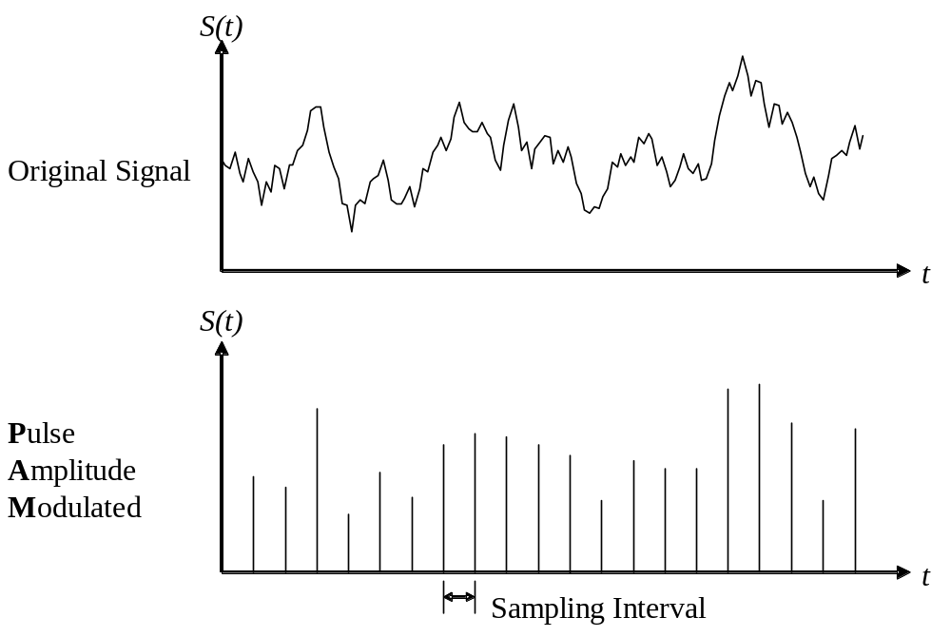
Figure 1: Conversion of analog signal to discrete signal using PAM.

However, the amplitude of each pulse has an infinite number of possible levels. Digitally storing all the information of the PAM signal would still require infinite storage space. The storage space of each pulse amplitude must be limited by quantizing the amplitude value and setting the maximum allowable value. This will limit the number of bits necessary to store the number. (Figure 2).

For instance, we want to use only 8 bits to store each sample, and the maximum possible value of the analog signal is 10, then we can quantize the signal into multiples of ¹⁰/₂₅₆ (0.03906). Each number will be represented as an 8-bit binary number between 0 and 255. To approximately reconstruct the original analog signal, each 8-bit sample must be multiplied by 0.03906.
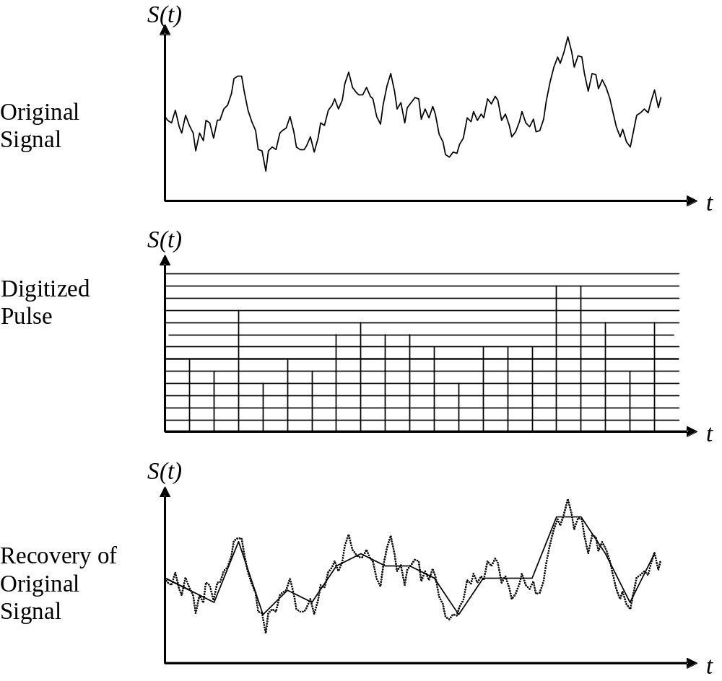
Figure 2: Conversion of analog signal to digital signal through PCM.

In the Fourier transform of an analog signal, the bandwidth is the maximum frequency in the signal. If we limit the bandwidth of the original signal, we eliminate the high-frequency components. If we then sample the signal at a sampling rate greater than or equal to twice this bandwidth, this discrete signal contains all the information of the original signal (by the Nyquist criterion). The bandwidth-limited signal can be reconstructed exactly from the discrete signal by digital-to-analog conversion (decoding).

For instance: The Fourier transform of an analog voice signal shows that most of the signal frequencies are between 100 Hertz and 4800 Hertz. If we use a low-pass filter to limit the signal bandwidth to 4000 Hertz, we will still be able to understand the voice signal (though consonant sounds with high-frequency components such as “p” and “t” may sound alike). If we sample the voice data at 8000 samples per second, we can recover all frequencies up to 4000 Hertz when we decode the PCM data.

The number of bits per sample is also important to accurately reproduce an analog signal. Using an insufficient number of bits results in quantizing (digitizing) distortion, where the decoded signal will have the same frequency range but the relative amplitudes of each frequency will be different than the original signal.

Voice data has a dynamic range as high as 50 dB. Since most digital telephone transmissions use 8 bits per sample, quantizing distortion can be significant for samples taken at low signal amplitudes. To capture large signal fluctuations, the standard telephone PCM process (the DS1 standard) compresses the analog signal to capture a larger dynamic range (see Figure 3). At high signal amplitudes, the difference between PCM levels is a large signal voltage. At low signal amplitudes, the difference between PCM voltage levels is a small voltage. The compression process greatly reduces the quantizing distortion for samples at low signal levels. The sampling frequency is 8000 Hz, so the total data transfer rate is 64,000 bits per second.

Audio compact discs reproduce sound far more accurately than digital telephone transmissions. They also use PCM to encode the audio signals, but the voltage scale is not compressed. They contain digital audio data at a rate of 44,100 samples per second, which allows frequencies of up to 22,050 kHz to be reproduced. Each sample consists of 16 bits of data, providing up to 96 decibels of dynamic range. The improved fidelity requires a data transfer rate of 705,600 bits per second, 11 times as much data as a phone transmission.

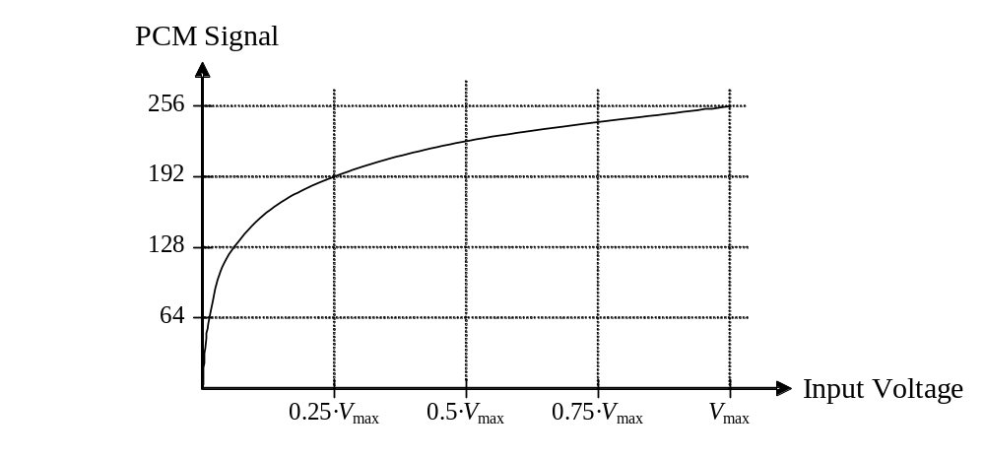
Figure 3: Conversion from signal voltage to PCM level in DS1 telephone system.

2. Sampling and the Nyquist Criterion

When sending a digital signal over a transmission line, the sampling rate of the signal determines the bandwidth required for successful transmission. Level detection and regeneration of a digital signal allows the signal to be transmitted with a significantly smaller bandwidth than the absolute bandwidth of the signal.

A very important question is how fast we can send data, in bits per second, over a channel. Data rate depends on three factors:
1. The bandwidth available
2. The levels of signals we can use
3. The quality of the channel (the level of the noise).

Two theoretical formulas were developed to calculate the data rate:
- Nyquist theory for a noiseless channel,
- Shannon theory for a noisy channel.

The Nyquist’s Criterion defines the minimum sampling rate needed to faithfully reproduce a sampled waveform. If f is the highest frequency in the sampled waveform, the Nyquist sampling rate, Ns, is given by the relation Ns = 2f. If f is in hertz, the sampling rate will be in samples per second. The time interval, Ts, between samples is given by the relation
Ts = 1/Ns = 1/2f = 0.5/f
Where Ns is the Nyquist sampling rate, and f is the highest frequency in the sampled waveform.

For a noiseless channel, the Nyquist bit rate formula defines the theoretical maximum bit rate:

In this formula, Bandwidth is the bandwidth of the channel, L is the number of signal levels used to represent data, and Bit Rate is the bit rate in bits per second. If two level signals signal encoding is used, Bit Rate is double of Channel Bandwidth.

Example 1: Consider a noiseless channel with a bandwidth of 3000 Hz transmitting a signal with two signal levels. The maximum bit rate can be calculated as:
Example 2: Consider the same noiseless channel, transmitting a signal with four signal levels (for each level, we send two bits). The maximum bit rate can be calculated as:
The Nyquist criterion determines the sampling rate necessary to capture all the information of an analog signal with a discrete sequence (taken by sampling the signal at a certain rate). The signal must be sampled at a rate of twice the signal bandwidth (Ω_{s} is the sampling frequency):
Ω_{s} > 2B
Another way to present the Nyquist criterion is that the discrete samples must capture the amplitude of each frequency in the Fourier transform of the signal at that point in time, and sum these amplitudes. If there is a sinusoidal component to the signal with a frequency of greater than one-half the sampling frequency , the same contribution to the signal could be made by a sinusoidal waveform at a lower frequency (Figure 4 a). If a sinusoidal component has a frequency exactly one-half the sampling frequency, the discrete samples cannot determine the correct amplitude of this component, since the samples may be out of phase with this component (Figure 4 b). Only when the sinusoidal component has a frequency less than one-half the sampling frequency will the component be correctly sampled (Figure 4 c).
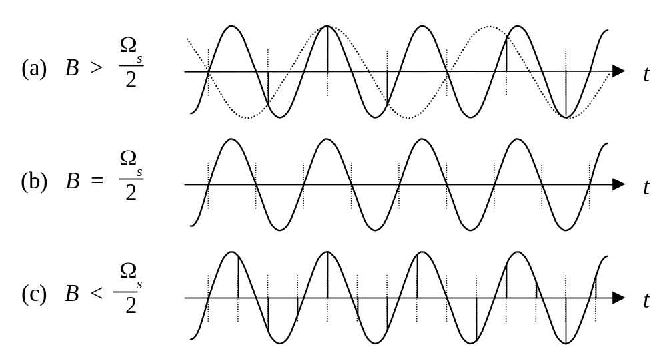
Figure 4: Sampling a sinusoidal signal at different sampling frequencies Ω_{s} .

The reverse of the Nyquist criterion states that if an analog signal has bandwidth of one-half Ω_{s} or greater, it can capture all the sampling information of a discrete signal sampled at a rate of Ω_{s.}
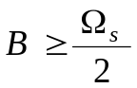
This statement is valid because a sinusoidal component can represent the change in value between two adjacent samples if its frequency is 1/2 the sampling frequency. The resulting frequency domain representation will be comprised of components whose frequency is no greater than 1/2 the sampling frequency.
The limited-bandwidth signal (Figure 6) contains all the sampling information present in the discrete signal. To regenerate the original discrete signal, it must be again sampled at the correct phase and frequency.
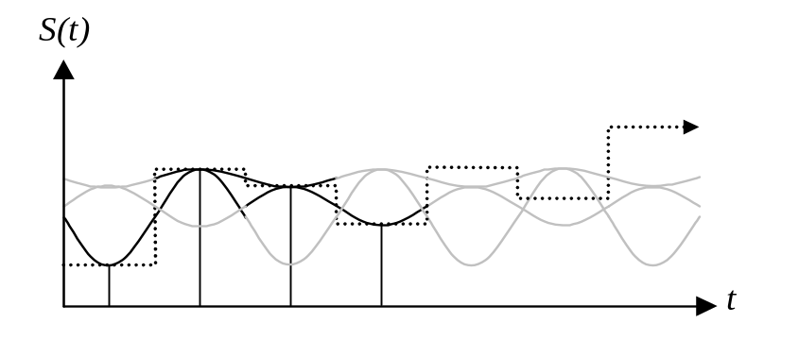
Figure 5: Adjacent samples in a discrete signal can be constructed
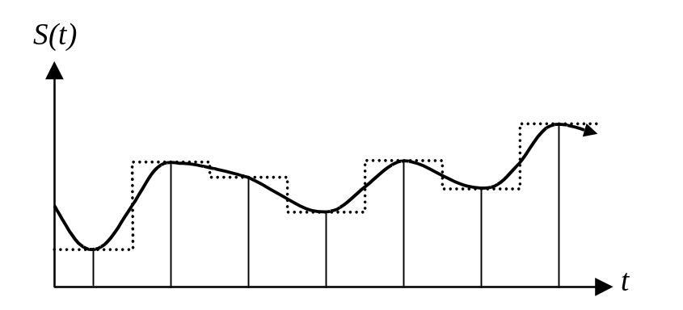
Figure 6: The limited-bandwidth signal captures the information in the discrete signal but does not replicate the signal.

Example:
A square wave represents a discrete signal comprised of 1’s and 0’s, with a sampling frequency of twice the square wave frequency. If we can sample at the correct phase and frequency, what bandwidth is necessary to transmit a 2000 Hz square wave the signal?

A square wave at 2000 Hz requires a sampling rate of 4000 Hz. According to the Nyquist criterion, a sampling rate of 4000 Hz requires a bandwidth of 2000 Hz or greater. Figure 7 shows that a sine wave at 2000 Hz can hold the same information as a 2000 Hz square wave if it is sampled at the correct phase and frequency. If we had more than 2000 Hz in bandwidth available, we could produce a signal that looked more like the original square wave, and it could carry the same sampling information as the square wave.
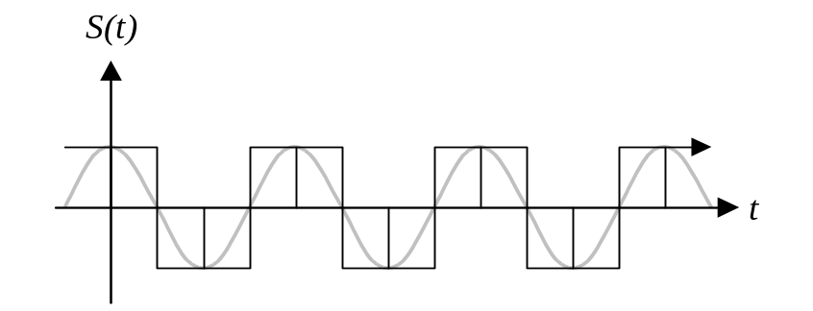
Figure 7: A sine wave holds the same sampling information as a square wave.

Digital signals are simply discrete signals with a limited number of possible voltage levels. A discrete signal is sensitive to noise, so the signal at the output of the transmission line will not be identical to the original signal due to attenuation of some signal components. In a digital signal, the maximum distortion introduced by the noise of the transmission line must be smaller than the difference between two adjacent signal levels. However, the bandwidth of a digital signal will be identical to the bandwidth of a discrete signal with the same sampling frequency.

3. Digital Data Encoding Schemes

When digital data is transmitted, it must be mapped to a signal pattern. The signal pattern should make transmission as reliable as possible, while being simple to decode. In the simplest encoding, a “1” is converted to signal voltage high, and a “0” is converted to signal voltage low. This is called Non-Return to Zero-Level (NRZ-L) encoding.
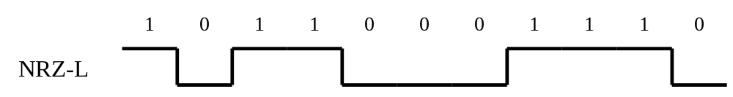
Depending on how the digital data is transmitted, other encoding schemes may provide more reliable data encoding:
Non-Return to Zero-Mark (NRZ-M):
0: No transition
1: Signal transition (low to high or high to low)
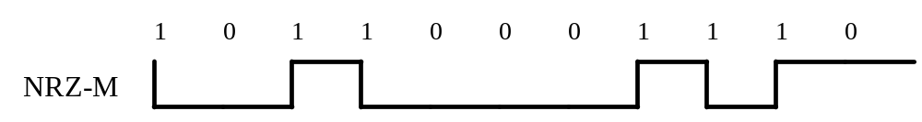

Non-Return to Zero-Space (NRZ-S):
0: Signal transition (low to high or high to low)
1: No transition
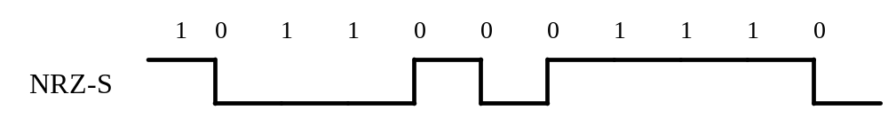

Return to zero (RZ):
0: Signal low
1: Signal high (first half) / Signal low (second half)
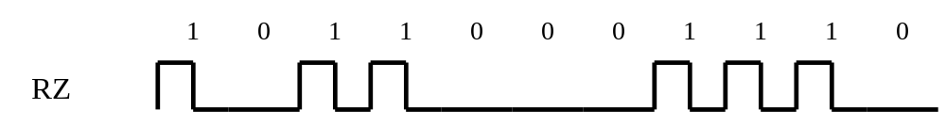

Manchester Encoding, or Biphase-Level:
0: Signal low (first half) / Signal high (second half)
1: Signal high (first half) / Signal low (second half)
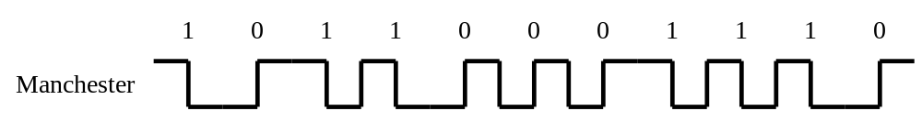

Biphase-Mark:
0: Transition at start of interval
1: Transitions at start and middle of interval
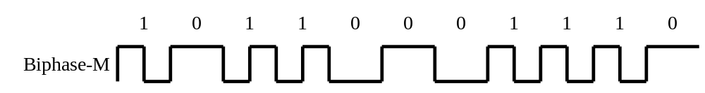

Biphase-Space:
0: Transitions at start and middle of interval
1: Transition at start of interval
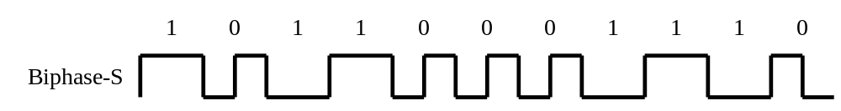

Differential Manchester Encoding:
0: Transitions at start and middle of interval
1: Transition at middle of interval
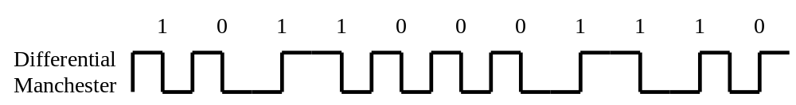

Delay modulation (Miller):
0: transition at start of interval only if preceded by 1
1: transition in middle of interval
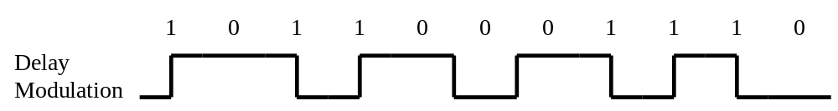

4. Channel Capacity

A large number of criteria can be used to measure the effectiveness of a communication system to see if it is ideal or perfect. Some of these criteria are: cost, channel bandwidth used, required transmitter power, signal-to-noise ratio at various points of the system, probability of bit error for digital systems, and time delay through the system. There are four concepts that are related to one other.

- Data rate: This is the rate, in bits per second, at which data can be communicated. Bandwidth: This is the bandwidth of the transmitted signal as forced by the transmitter and the nature of the transmission medium, expressed in cycles per second, or Hertz.
- Noise: The average level of noise over the communication path.
- Error rate: The rate at which error occur, where an error is the reception of a 1 when a 0 was transmitted, or the reception of a 0 when a 1 was transmitted.

All transmission channels of any practical interest are of limited bandwidth. The limitations arise from the physical properties of the transmission medium or from planned at the transmitter on the bandwidth to prevent interference from other sources. Accordingly, we would like to make as efficient use as possible of a given bandwidth. For digital data, this means that we would like to get as high a data rate as it is possible at a particular limit of error rate for a given bandwidth.

Channel bandwidth is the signal frequency band (f_{max} –f_{min}) in Hertz that could be transmitted without significant attenuation. “Significant” in this definition means less than 50% power, so channel bandwidth is the frequency band of the signals, at which signal output power is more or equal to 50% of input signal power.

In digital systems the optimum system might be defined as the system that minimizes the probability of bit error at the system output subject to limitations on transmitted energy and channel bandwidth. Thus bit rate error and signal bandwidth are of prime importance.

Let us consider the case of a channel that is noise-free. In this environment, the limitation on data rate is simply the bandwidth of the signal. A formulation of this limitation, due to Nyquist, states that if the rate of signal transmission is 2B, then a signal with frequencies no greater than B is sufficient to carry the data rate. The converse is also true: Given a bandwidth of B, the highest signal rate that can be carried is 2B. This limitation is due to the effect of inter symbol interference, such as is produced by delay distortion. The result is useful in the development of digital-to-analog encoding schemes. If the signals are binary (two voltage levels), then the data rate that can be supported by B Hz is 2B bps.

Example (A): consider a voice channel being used, via modem, to transmit digital data. Assume a bandwidth of 3100 Hz. Then the capacity, C of the channel is 2B=6200 bps (Nyquist’s bandwidth). However, signals with more then two levels can be used, that is, each signal element can represent more than one bit. For example, if four possible voltage levels are used as signals, then each signal element can represent two bits. With multilevel signaling, the Nyquist formulation becomes
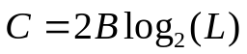
where L is the number of discrete signal or voltage levels. Thus, for M=8, a value used with some modems, C becomes 18,600 bps.

So, for a given bandwidth, the data rate can be increased by increasing the number of different signals. However, this places an increased load on the receiver. Instead of distinguishing one of two possible signals during each signal time, it must distinguish one of L possible signals. Noise and other impairments on the transmission line will limit the practical value of L. Thus, all other things being equal, doubling the bandwidth doubles the data rate.

5. Noisy Channel: Shannon Capacity

In reality, we cannot have a noiseless channel; the channel is always noisy. Claude Shannon introduced a formula, called the Shannon capacity, to determine the theoretical highest data rate for a noisy channel:
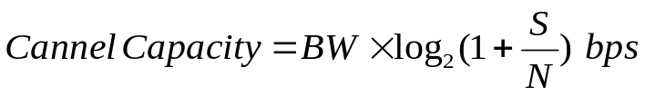
In this formula, Bandwidth is the bandwidth of the channel, S/N is the signal-to-noise ratio, and Capacity is the capacity of the channel in bits per second. The signal-to-noise ratio is the statistical ratio of the power of the signal to the power of the noise. Note that in the Shannon formula there is no indication of the signal level, which means that no matter how many levels we use, we cannot achieve a data rate higher than the capacity of the channel. In other words, the formula defines a characteristic of the channel, not the method of transmission.

Example 1: Consider an extremely noisy channel in which the value of the signal-to-noise ratio is almost zero. In other words, the noise is so strong that the signal is weak. For this channel the capacity is calculated as

This means that the capacity of this channel is zero regardless of the bandwidth. In other words, we cannot receive any data through this channel.

Example 2: We can calculate the theoretical highest bit rate of a regular telephone line. A telephone line normally has a bandwidth of 3000 Hz (300 Hz to 3300 Hz). The signal-to-noise ratio is usually 3162. For this channel the capacity is calculated as:
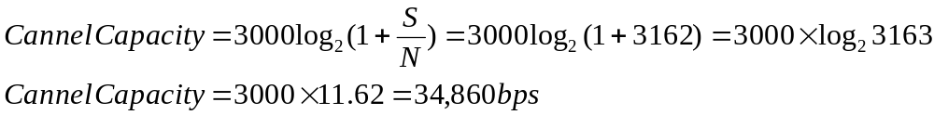
This means that the highest bit rate for a telephone line is 34,860 Kbps. If we want to send data faster than this, we can either increase the bandwidth of the line or improve the signal-to-noise ratio.

Now consider the relationship between data rate, noise, and error rate. The presence of noise can corrupt one or more bits. If the data rate is increased, then the bits become “shorter” so that more bits are affected by a given pattern of noise. Thus, at a given noise level, the higher the data rate, the higher the error rate. For a given level of noise, we would expect that greater signal strength would improve the ability to correctly receive data in the presence of noise. The key parameter involved in this reasoning is the signal-to-noise ratio (S/N), which is the ratio of the power in a signal to the power contained in the noise that is present at a particular point in the transmission. Shannon showed that (for the case of signal plus white Gaussian noise) a channel capacity C (bits/sec) could be calculated such that if the rate of information R (bits/sec) was less than C, the probability of error would approach zero. The equation for C is:
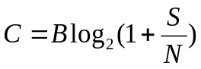
Where B is the channel bandwidth (in Hz) and S/N is the signal-to-noise power ratio (watt/watt, but not dB) at the input to the digital receiver.

The channel capacity is a non-dimensional number; we normally quote the capacity as a rate, in bits/second.

Let us consider previous example (A). Assume value of S/N for a voice-grade line is 30 dB, or a ratio of 1000/1. Thus
This represents the theoretical maximum that can be achieved. In practice, however, only much lover rates are achieved. One reason for this is that the formula assumes white noise (thermal noise). Impulse noise is not accounted for, nor attenuation or delay distortion.

The capacity indicated in the proceeding equation is referred to us the error-free capacity. Shannon provide that if the actual information rate on a channel is less than the error-free capacity, than it is theoretically possible to use a suitable signal code to achieve error-free transmission through the channel. Shannon’s theorem unfortunately does not suggest a means for finding such codes, but it does provide a measure by which the performance of practical communication schemes may be measured.

- In practice, we need to use both methods to find what bandwidth of what signal level we need. Let us show this by an example.

Example 3: We have a channel with a 1 MHz bandwidth. The SNR for this channel is 63; what is the appropriate bit rate and signal level?
Solution: First, we use the Shannon formula to find our upper limit.

Although the Shannon formula gives us 6 Mbps, this is the upper limit. For better performance we choose something lower, for example 4 Mbps. Then we use the Nyquist formula to find the number of signal levels.

Conclusion

- Bit rate (number of bits per second) and bit interval (duration of 1 bit) are terms used to describe digital signals.
- Bit rate and bandwidth are proportional to each other.
- The Nyquist formula determines the theoretical data rate for a noiseless channel.
- The Shannon capacity determines the theoretical maximum data rate for a noisy channel.

6. Appendix

a. Nyquist criterion
The greatest part of information sources is analog, like sound. Today's telecommunication systems are mostly digital signals, so the most important step toward communicating is a signal digitization. In this case, signal is a voltage or current representation of the real world phenomena. Word digital means discrete value of a signal at discrete periods of time (intervals). These discrete intervals are very important and defined by the Nyquist's criterion.
The Nyquist's criterion says that a signal must be sampled at least twice as often as its highest frequency to enable correct reconstruction of the signal when transmitted. Real world signals are very irregular. For example: speech or music. Frequency analysis of the music signal shows that there are components that have very high frequencies. Theoretically, a signal can have all of the frequencies in the spectrum, so that if one wants to take samples of such signal, respecting the Nyquist's criterion, sampling frequency goes to infinity. Practically that is unobtainable. But fortunately, music, speech, etc. have almost all of the components inside a bandwidth of around 0-4 kHz for speech or 0-12 kHz for music. Upper frequency is taken as a highest frequency of the signal, and all of the components above are being filtered out using a low-pass filter. According to Nyquist's criterion, sampling rate is e.g. 8 kHz for speech. Every sample gets its 8 bits code word and that makes 8bit * 8kHz = 64 kbit/s speech bit rate used as a basic rate in N-ISDN.
Let's prove now the Nyquist's criterion. Knowledge in Fourier analysis and a bit of mathematical analysis is required to understand the following. We'll assume a real sampling signal made of pulses of the duration time 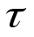distanced for period T (Figure 1-b and Figure 2 below). Samples carrying signal (Figure 1-c) will be produced by the multiplication of the original signal (Figure 1-a) and the sampling signal (Figure 1-b). Spectrum of the original signal Xi(t) is defined by the Fourier transformation as follows :
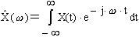
Spectrum in Figure 2 below is a speech spectrum. One can see that almost whole spectrum is placed under the frequency of 4 kHz.
To prove Nyquist’s criterion, we'll have to find the spectrum of the signal shown in Figure 1-c. First step toward this spectrum is spectrum of the sampling signal shown below in Figure 3.

The spectrum shown on the right is the real part (positive frequencies) of the spectrum of the real "red" signal on the left. Theoretically, we assume an ideal rectangular pulse sampling signal shown in Figure 3 above in black. Pulse duration time is , and distance between two neighboring pulses is T. The spectrum of that signal is the same as the one shown above, but the spectral components have no width, they are delta-functions multiplied with the amplitude.
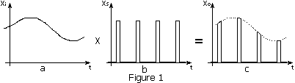

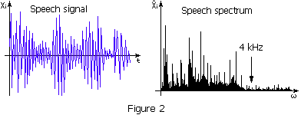

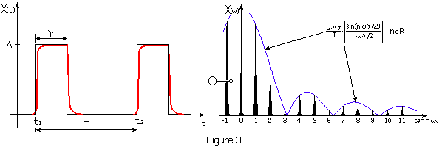
Since the distance between two neighboring original spectrums is rate of sampling, signal must be sampled at least twice as often as its highest frequency. Next formula is formalization of that law.

One has to be careful with the term bandwidth. It considers band width from frequency 0 Hz to B Hz. If one takes that in account, it is maybe better to say that sampling rate has to be at least twice faster than the highest frequency fh. Frequency fh is the upper low pass filter frequency.
Nyquist's criterion is proved for the sampling of the electrical signal that is an image of the real world phenomena, but it can be applied elsewhere. One of the school examples is turning of the wheel in wrong direction while in a movie. Why does it happen? We can mark a point on the wheel, and watch that point only. Making movie is taking pictures every "t" time. If the point on the wheel makes exactly one turn inside the time "t", we'll see that the wheel is not turning at all. If we increase sampling rate, we'll see the point on the wheel turning in wrong direction. If we increase the sampling rate to be twice faster than a wheel rotation speed, we'll finally see the point on the wheel turning in right direction. Even in this case, Nyquist's criterion has to be respected. Of course, in real movies, details on the wheel determine the right sampling rate.

